**Uncommon Solutions**

**Group 3**

**Design Document**

**UNCOMMON SOLUTIONS DESIGN DOCUMENT**

**Prepared By**

|  |  |
| --- | --- |
| Document Owner(s) | Project Role |
| Hither Guzha | Technical Writer |

**Requirements Version Control**

|  |  |  |  |
| --- | --- | --- | --- |
| Version | Date | Author | Change Description |
| 1.0 | 11/16/2019 | Hither Guzha | Document creation |

**Summary Details**

|  |  |
| --- | --- |
| Participants | Name(s) |
| Project Manager: | Michael Kiefer |
| Project Team: | Hither Guzha – Technical Writer  Andrew Benson - Software Engineer  Donn Eddy - UX/HCI  Sean Mooneyham - Integration Engineer  Chase Thorpe - Test Engineer |
| End Users: | HR Departments |
| Description w/ Goal: | The purpose of this project is the implementation of an HR database and front end for personnel tracking. This document is to detail the design and architecture of the Uncommon Solutions Application. |

INTRODUCTION 4

1.1 Purpose 4

1.2 Background 4

1.3 Scope 4

1.4 Assumptions 4

1.5 Constraints 4

1.6 Risks 4

1.7 Design Considerations 4

2 SYSTEM OVERVIEW 5

2.1 System Design 5

3 SYSTEM ARCHITECTURE DESIGN 6

3.1 Database Design 6

3.2 Class Design 6

3.3 User Interface 6

4 SYSTEM INTERGRITY CONTROLS 7

5 APPROVALS 9

# 

# INTRODUCTION

## Purpose

The purpose of this document is to detail the design and architecture of the Uncommon Solutions HR Management System. The Uncommon Solutions HR Management software is being developed using an Agile SDLC framework. While this document describes the design aspects of certain features within the Uncommon Solutions HR Management System, specific details about the requirements and design considerations that were made to meet those requirements can be found in the system requirement specifications document. This document has the necessary information required to effectively define the architecture and system design in order to give the project team guidance on the architecture of the system to be developed.

## Background

The Uncommon Solutions HR Management System will be designed in a way that makes it easy to support multiple platforms such as Windows, iOS and Android. This web-based tool is useful for storing and providing access to individual personnel records, and for all processes that HR want to track and from which they hope to gather useful and purposeful data. The HR system will be implemented using AWS Elastic Compute Cloud (EC2) and Amazon’s Relational Database Service (RDS).

## Scope

This document describes the overarching design and guiding principles of the

Uncommon Solutions HR Management System. This is a living document and will be updated as changes are made to the HR Management Systems.

## Assumptions

The following assumptions are relevant to the design of the proposed system:

* The proposed new system will leverage the Uncommon Solutions HR architecture.
* The existing architecture and system design will be used including all existing components and sub-systems.
* It is assumed that additional functionalities will be added to the proposed solution.

## Constraints

* There is no hardware, software technical constraints identified with this project.
* System interoperability may be a constraint since the design will leverage free tier AWS EC2 instance and RDS.

## Risks

There are very minimal risks associated with the system design.  This is primarily because the existing system design and architecture will not be modified to meet the needs of the proposed solution. Ongoing maintenance of the system will also be a concern.

## Design Considerations

The major design considerations for the proposed solutions are related to system performance and scalability of the solution. Data center is hosted in AWS which provides a tremendous amount of flexibility in terms of scaling the performance. Processor speed, memory, peripherals, and stakeholder support will be factored in the design.

# SYSTEM OVERVIEW

## System Design

The product system design utilizes two different AWS services, Elastic Compute Cloud (EC2) and Amazon’s Relational Database Service (RDS). Using AWS as a platform for the application is the most cost-effective way to host the application while also providing access to the application for all project team members and product owners. AWS is an excellent platform for quickly spinning up application prototypes.

The application uses Apache version 2.4.29 as a web server and is installed on the EC2 T2 instance and uses Ubuntu 18.04 as an operating system. All source code including the user interface and API will be on the apache server. The application uses a MySQL database installed on an RDS instance to house all the application data. To access the application the client or admin client simply connects to the EC2 instance currently located at “**ec2-54-145-217-172.compute-1.amazonaws.com**” OR “**54.145.217.172**”.

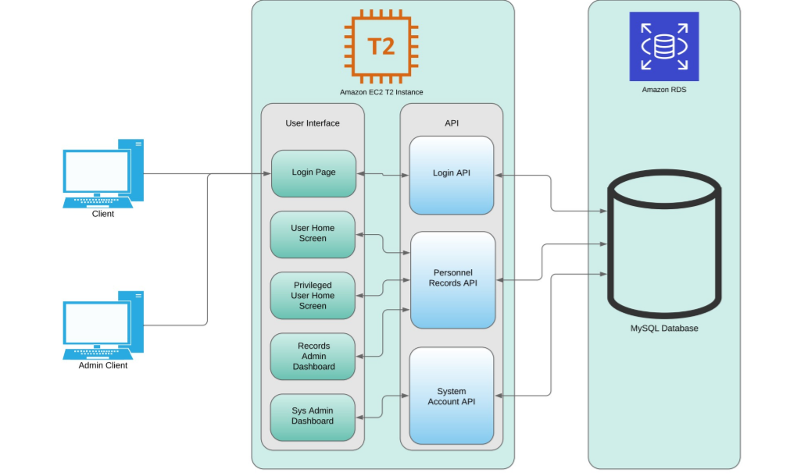

**Figure 1: The System Design Diagram**

# SYSTEM ARCHITECTURE DESIGN

## Database Design

The database design for this project is divided into two main sections; authentication data and personnel data. There is a relational connection between the two sections for most accounts, except those accounts for system administrators. The Data Design Diagram (DDD) provides a visual of the tables and their relationships, but a basic breakdown is described in the following sections.

The authentication data section is simple, containing the table with information on the individual user accounts and a linked table to log authentication attempts in. The presence of the AccessLogTable allows for database level tracking of frequency of failed login attempts as well as an audit log of all successful system logins. At this time, this is the only database level logging implemented for this program, though future revisions may incorporate this capability to all data tables for record-level audit tracking. For all users who are not system administrator accounts, the table entry in UserLoginTable will link to an entry in PersonnelRecordTable in a one-to one relationship.

The personnel data section is a little more complicated than that of the authentication data, but only to allow for more flexibility in data storage for individual records. Each entry in the PersonnelRecordTable can be a part of zero, one, or many groups based on the number of entries in the UserGroupTable that employee_number is associate with, this flexibility allows for personnel to work across multiple departments and have that reflected in their personnel record, something most systems do not accommodate. In much the same way, as personnel change jobs, the jobs themselves are still present and can be reassigned to a new personnel record to reflect the change in who is occupying that position without requiring the re-entry of the job title or job description. As individuals progress within the company, the number of training records, personnel records, and resumes on file can shift and grow with the individual, in order to effectively capture all their experience and capabilities. The same table is used to store contact information for both the employees and their emergency contacts, as we will have instances where an emergency contact is another employee of the company, and there’s no need to duplicate data in those cases.

Overall, it’s a simple database that takes advantage of the capabilities of the relational model to streamline data storage and avoid space allocation for empty records, while still allowing the flexibility for a large-scale employee record in the cases that warrant.

## Class Design

The design of the API uses a simple MVC pattern where the models use an Object-Oriented design and have standard attributes such as private properties that are accessible with getter and setter methods. Since the scope of the application is small only one controller will be used to handle all the database operations. Classes will be implemented to handle database connectivity, user login, and audit logging.

## User Interface

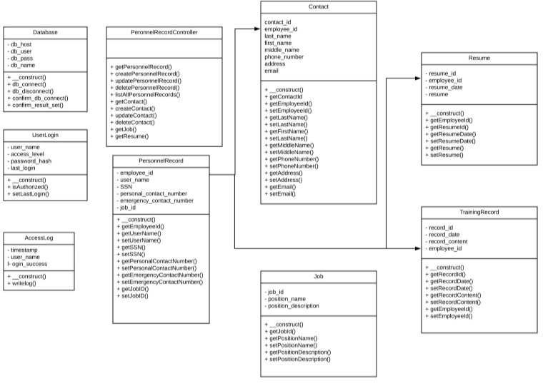

**Figure 2: The Data Design Diagram (DDD)**

# SYSTEM INTERGRITY CONTROLS

The following security and integrity are relevant to the design of the proposed system:

* Source code for the HR software components and products will be stored securely with need-to-know access controls applied.
* The system will have log files for all modification that will be maintained and preserved for future analysis.
* User passwords will be encrypted in the database.
* Internal security will be implemented to restrict access of critical data items to only Administrators, and all other users.
* Each employee will be restricted to only access their personnel data.
* Audit procedures will be implemented to meet control, reporting, and retention period requirements for operational and management reports
* Verification processes for additions, deletions, or updates of critical data
* The system will have the ability to identify all audit information by user identification, network terminal identification, date, time, and data accessed or changed.

# APPROVALS

I have read the above Project Plan and will abide by its terms and conditions and pledge my full commitment and support for the Project Plan.

Sign-off Sheet

**Prepared by** ___Hither Guzha_________________________

Technical Writer – Hither Guzha

**Approved by**___Michael Kiefer________________________

Project Manager– Michael Kiefer

**Approved by**___Andrew Benson_______________________

Project Team Member– Andrew Benson

**Approved by**___Donn Eddy___________________________

Project Team Member– Donn Eddy

**Approved by**___Sean Mooneyham_____________________

Project Team Member– Sean Mooneyham

**Approved by**___Chase Thorpe_________________________

Project Team Member– Chase Thorpe

**References:**